BISHNUPUR, BANKURA
Pin – 722122, West Bengal
UGCRecognized&StateGovernmentAidedConstituent College
UndertheUniversityof Bankura
Tel -(03244)252059
TeleFax–(03244)254427
e-mail–principal@ramanandacollege.org Website-www.ramanandacollege.org
Mobile-6297976619

Ref.No. (AccreditedbyNAACat B++) Date-01-05-2024

NOTIFICATION

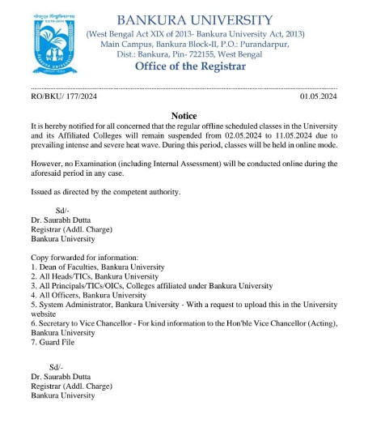
It is notified to all UG and PG students (2023-24) that in view of the latest notice issued by Bankura University, please attend your classes in the online mode as per your routine.

Principal,
Ramananda College,
Bishnupur,Bankura.

